Module Name: Login Page – Functional, UI Test Cases, Add product, Payment Process
Test Case ID: st_02
Webpage URL: https://www.flipkart.com/

Step 1 : Open Application
Step 2 : Enter Valid email Id/Mobile Number
Step 3 : Enter Valid password/OTP
Step 4 : Click Login to direct home page
Step 5 : Add product to cart
Step 6 : Procced To Pay
Step 7 : Make Payment Valid
And
Step 8 : Make Payment Failed due to some reason
Step 2 :
Step 1 :

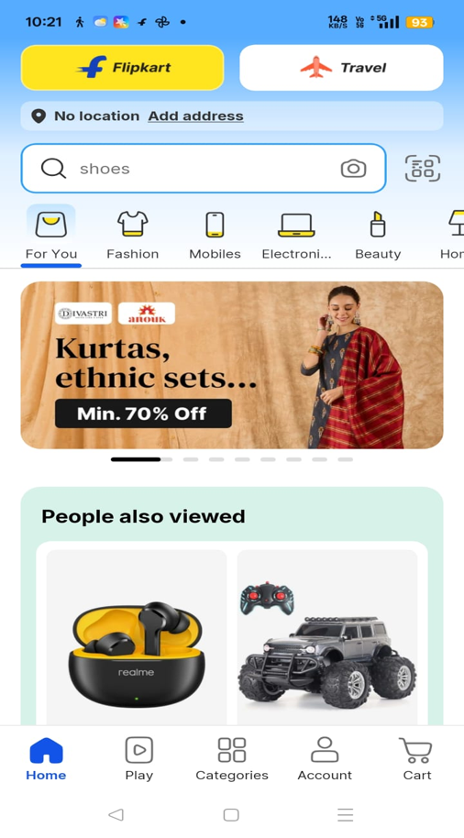
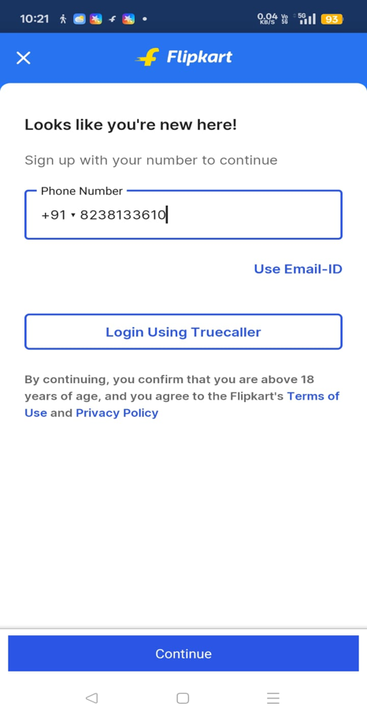

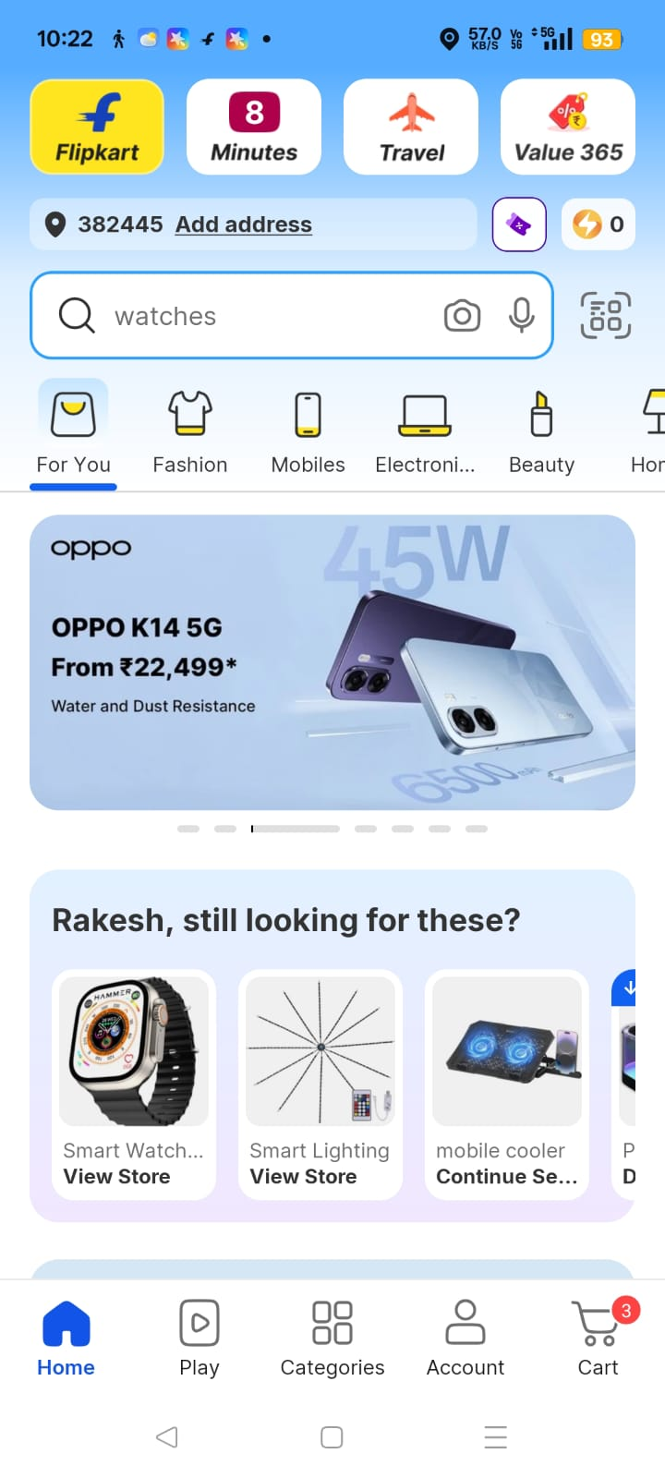
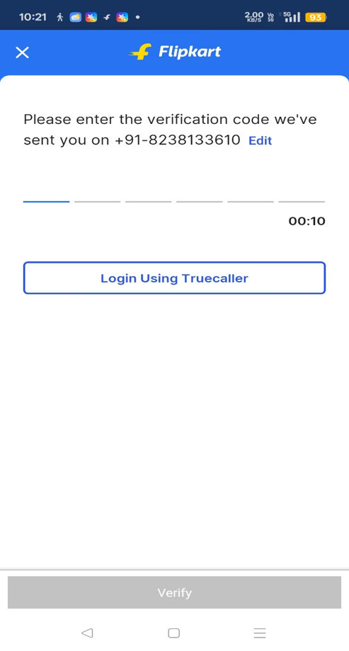
Step : 4
Step : 3

Step : 6
Step : 5
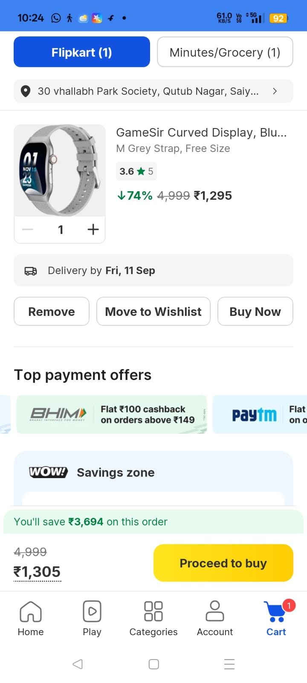
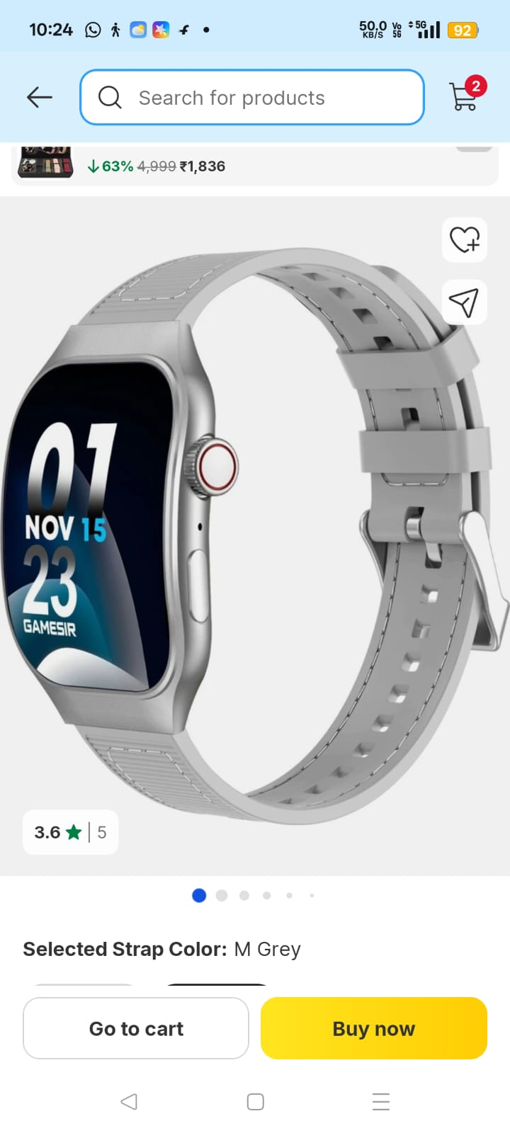

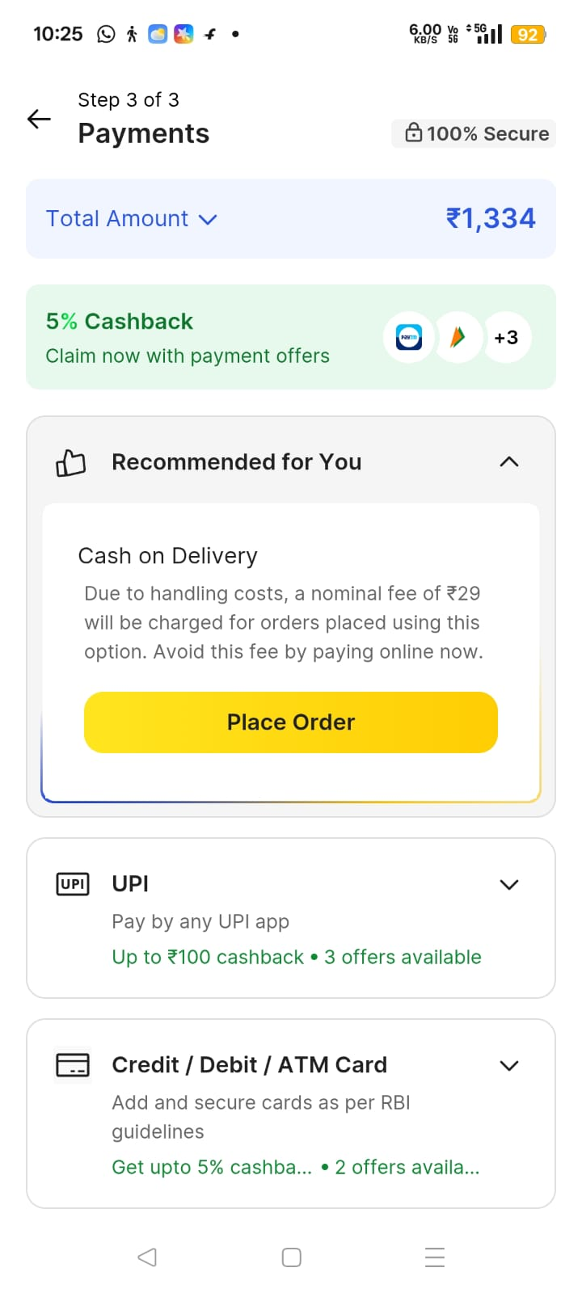
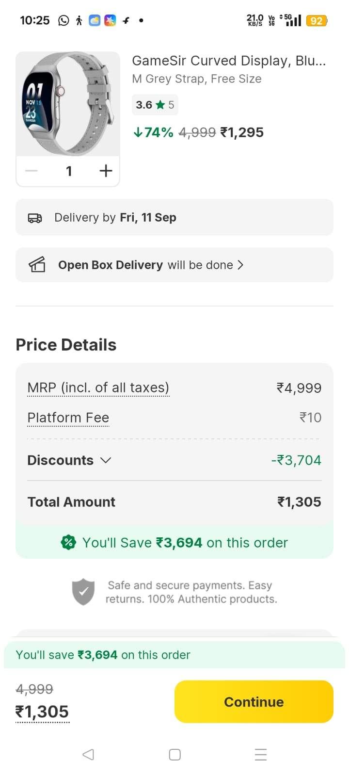
Step : 7
Step : 8

Step : 10
Step : 9

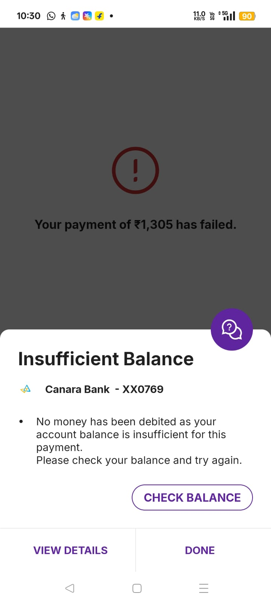
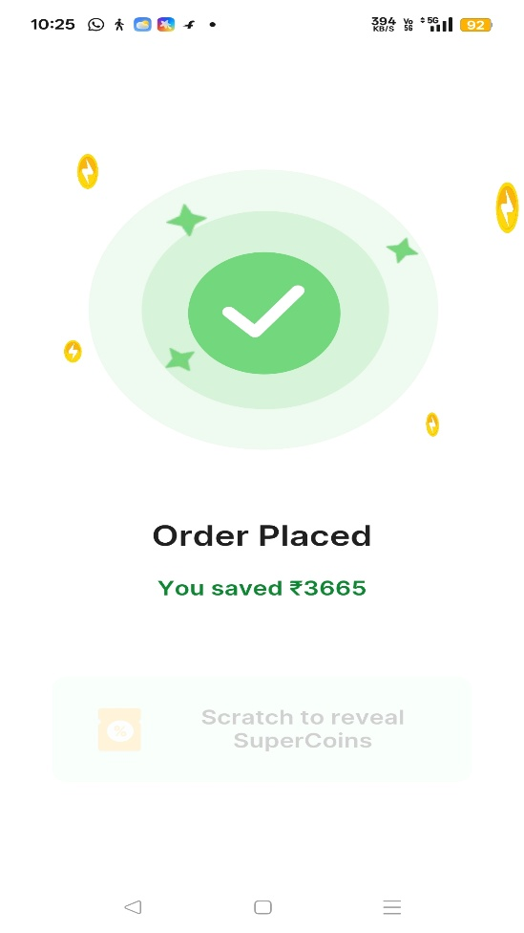

OR

Step : 7

